CO3

1. Input a line of text and display it on standard output.
2. Declare a variable and echo its value. For example, Declare a variable of
x and assign its value=10.
3. Using option ‘\b‘ – backspace with backslash interpretor ‘-e‘ which
removes all the spaces in between.
4. Using option ‘\n‘ – New line with backspace interpretor ‘-e‘ treats new
line from where it is used.
5. Using option ‘\t‘ – horizontal tab with backspace interpretor ‘-e‘ to
have horizontal tab spaces.
6.Using option ‘\v‘ – vertical tab with backspace interpretor ‘-e‘ to have
vertical tab spaces.
7.Using option ‘\r‘ – carriage return with backspace interpretor ‘-e‘ to have specified
carriage return in output.
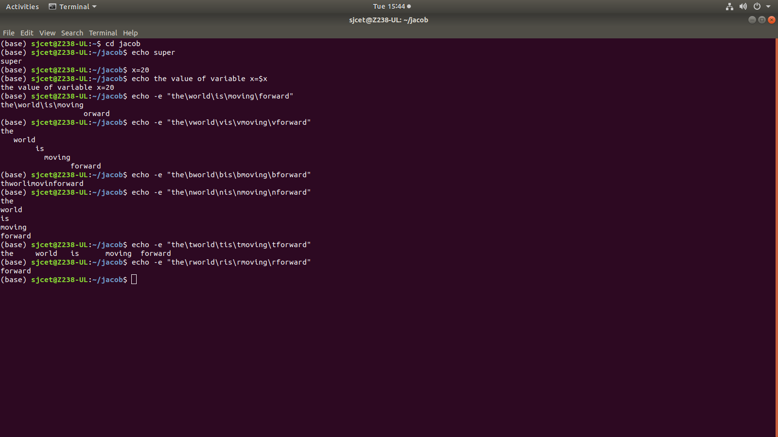
8.read

